Result Analysis

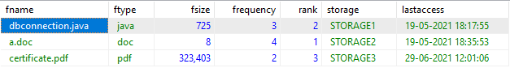

When the client send upload request to CMS, it check the duplication of file and also allocates a storage node having highest memory. Every time when the file is accessed by user, frequency for that file is updated and rank is updated for all files. Hence based on file access pattern files will be displayed to user based on rank. User can also see last access time details to know weather user requires the file for future or not. If file is not required, user can delete the file and free up memory in storage nodes.

For file security, every file is encrypted by CMS before storing in storage nodes. And also file compression is used to save storage memory.

When user downloads a file, CMS encrypts the file using a OTP and OTP is sent to mailed of user. Hence user can get his OTP and decrypt downloaded file.